Task 12 : Storage Bucket Security
Note: Actual AWS Console screenshots must be captured from your own account. This document includes placeholders showing where to insert them.

Task 1: Create Bucket & Upload MP3 Files
- Go to: AWS S3 Console
- Click Create bucket
- Bucket name → my-music-uploads (must be globally unique → add initials if needed)
Example: my-music-uploads-ka-2026
- Region → Asia Pacific (Mumbai)
- Keep:
- Block Public Access → Enabled
- Click Create bucket
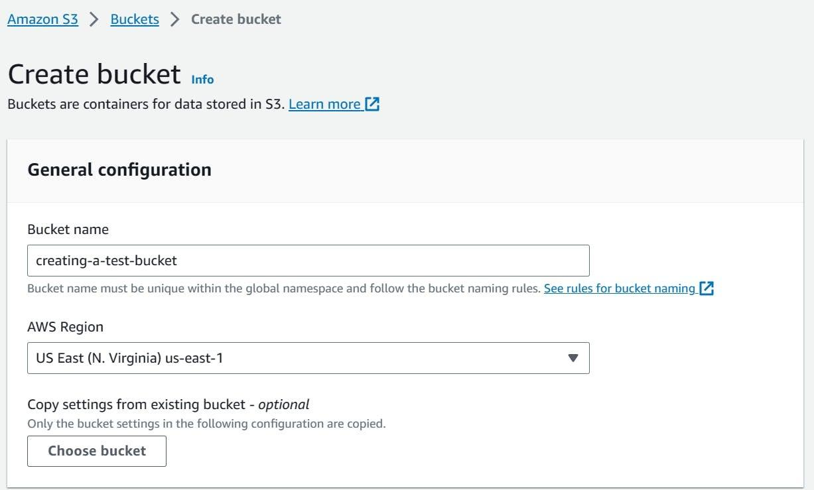
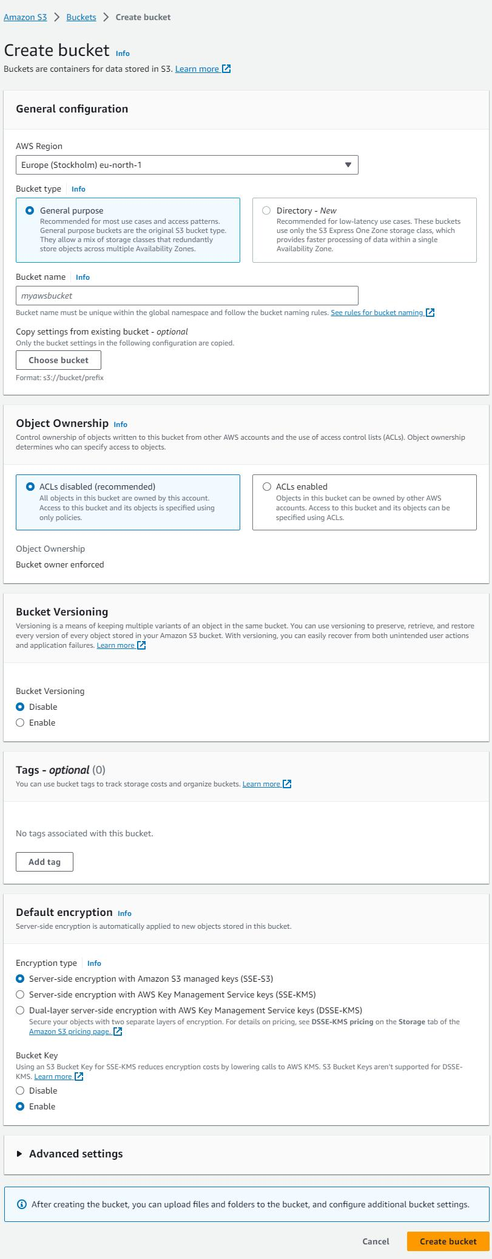
- Open bucket → Click Upload
- Add 2 .mp3 files
- Click Upload
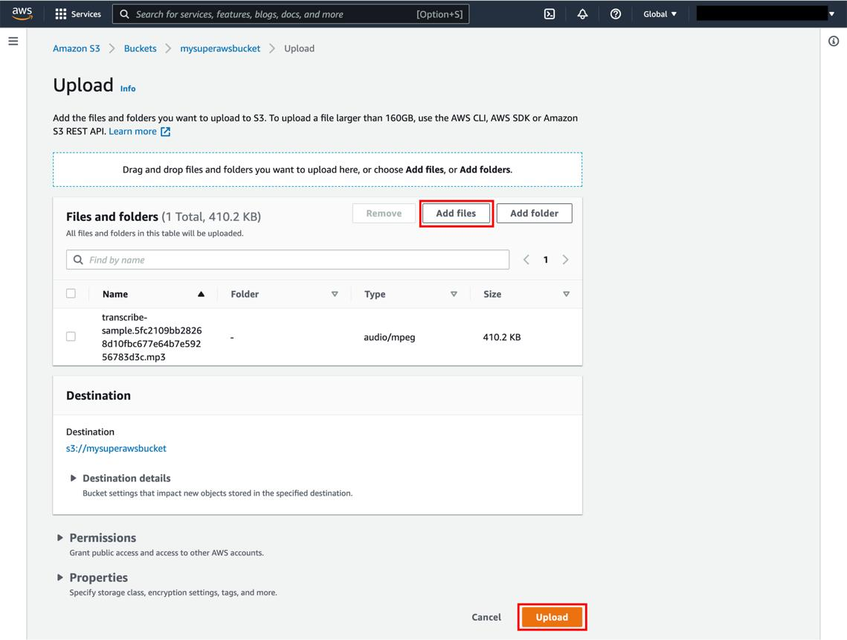
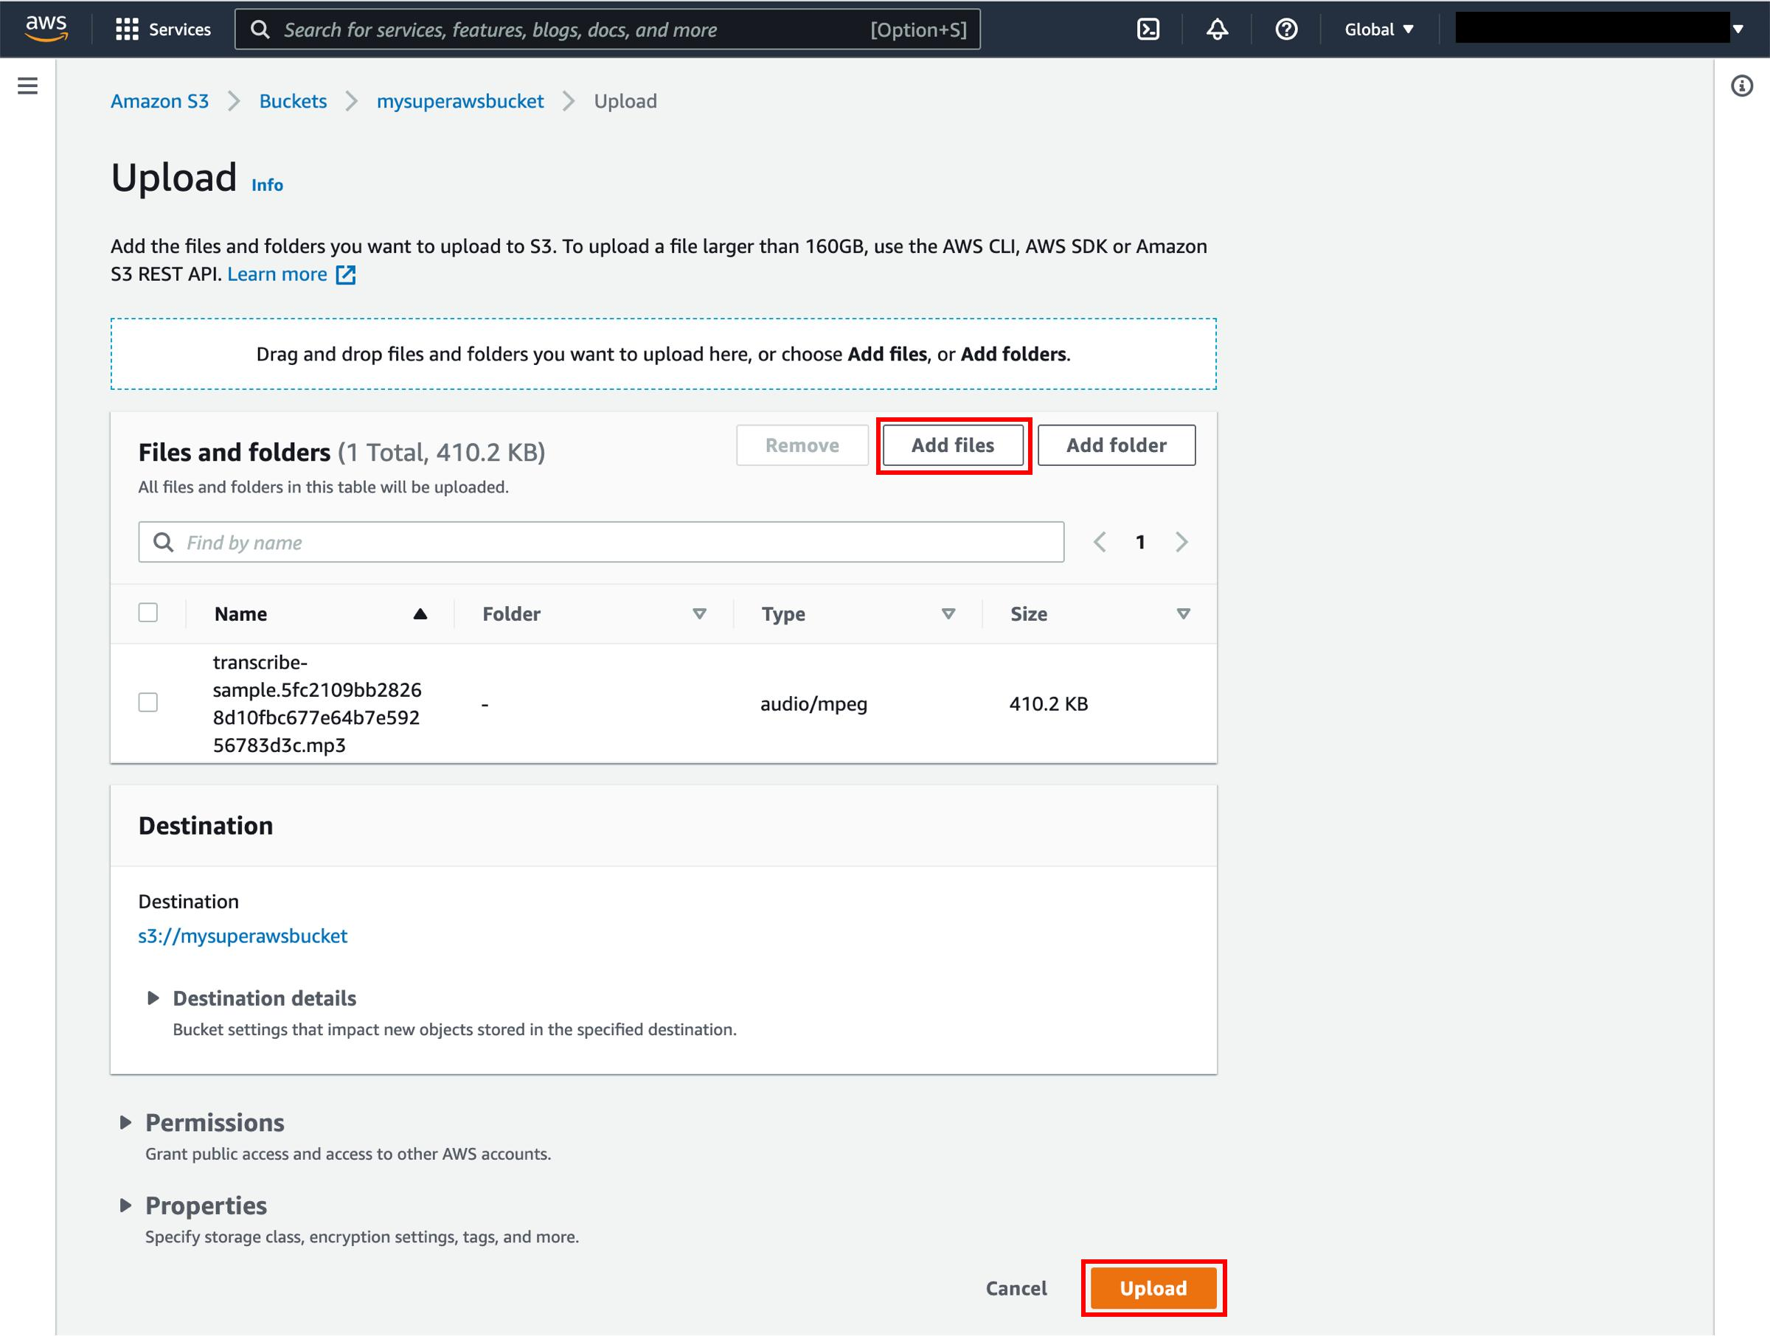

Task 2: Apply Bucket Policy
- Go to: AWS IAM Console
- Create a new user:
- Username: music-user
- Enable Programmatic or Console access
- Note the ARN:
- arn:aws:iam::123456789012:user/music-user
- Create IAM user.
- Copy IAM ARN.
- Apply bucket policy allowing s3:GetObject for that IAM user.
{
"Version": "2012-10-17",
"Statement": [
{
"Sid": "AllowSpecificUserDownload",
"Effect": "Allow",
"Principal": {
"AWS": "arn:aws:iam::123456789012:user/music-user"
},
"Action": "s3:GetObject",
"Resource": "arn:aws:s3:::my-music-uploads/*"
}
]
}

Task 3: Enable Server-Side Encryption
- Bucket → Properties → Default Encryption → Enable SSE-S3 (AES-256).
• Go to bucket → Properties
• Scroll → Default encryption
• Click Edit
• Select:
- Enable
- Encryption type: SSE-S3 (AES-256)
- Save
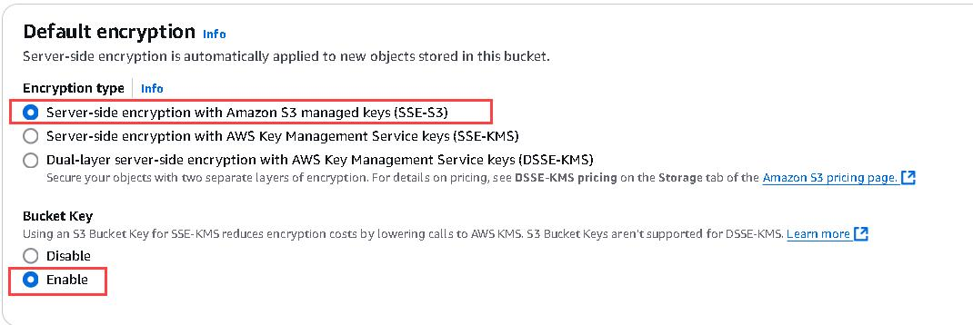
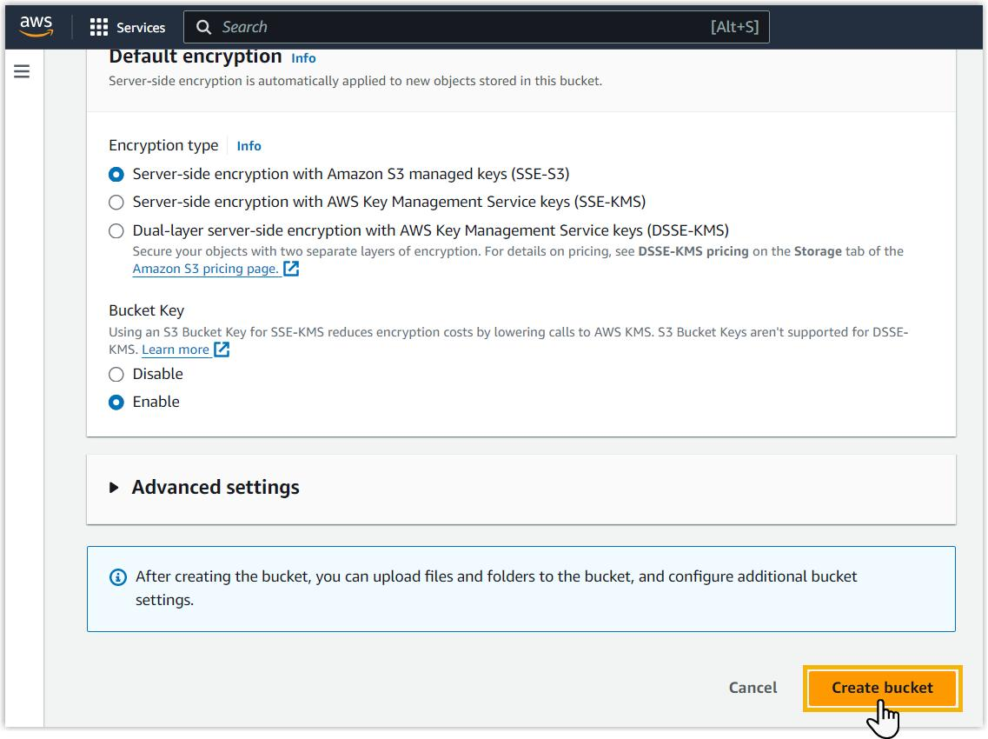

Task 4: Test Security
- Open object URL in Incognito/not logged in.
- Verify AccessDenied message
- Copy object URL:
- https://my-music-uploads.s3.amazonaws.com/song.mp3
- Open:
- Incognito mode OR
- Different browser (not logged in)

Task 5: IP Restriction Policy
- Apply IP restriction bucket policy.
- Save changes.
{
"Version": "2012-10-17",
"Statement": [
{
"Sid": "IPRestriction",
"Effect": "Deny",
"Principal": "*",
"Action": "s3:GetObject",
"Resource": "arn:aws:s3:::my-music-uploads/*",
"Condition": {
"NotIpAddress": {
"aws:SourceIp": "49.36.0.0/16"
}
}
}
]
}

